**MY SQL QUERIES**

**COFFEE SHOP SALES PROJECT**

**Clean and Convert Data**

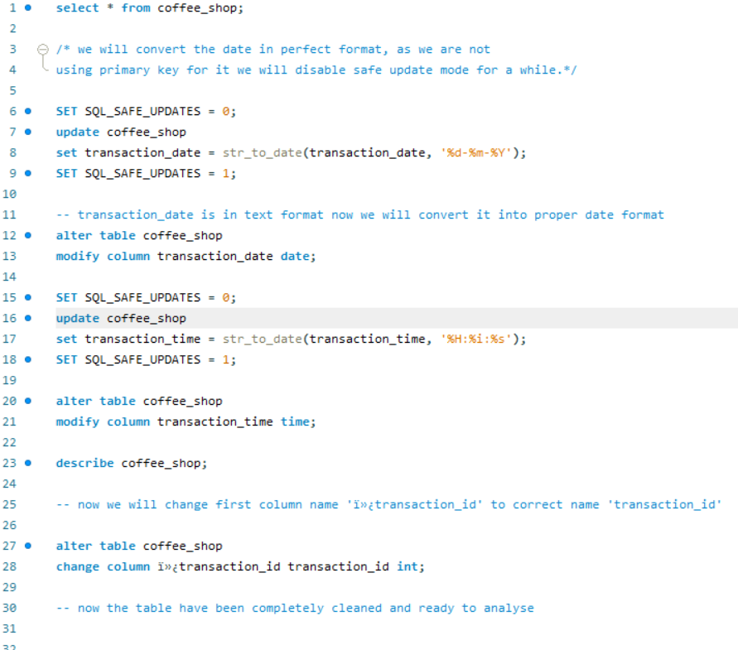

**TOTAL SALES**

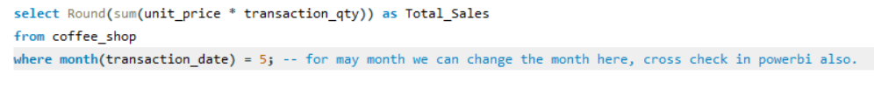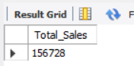

**TOTAL SALES KPI - MOM DIFFERENCE AND MOM GROWTH**

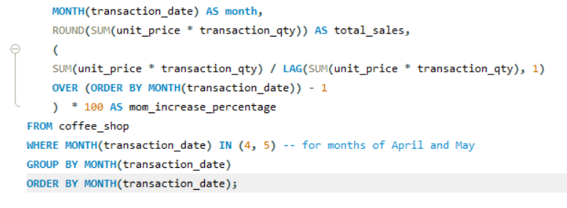

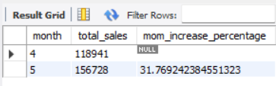

**Calculate the sales between the selected month and the previous month**

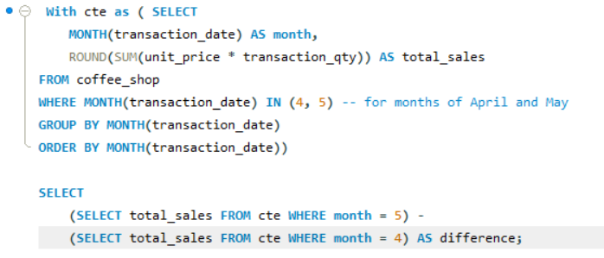

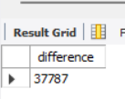

**TOTAL ORDERS**

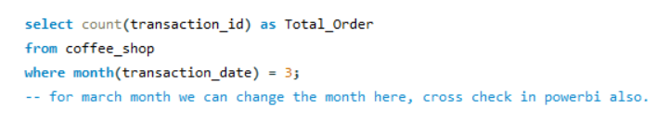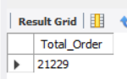

**TOTAL ORDERS KPI - MOM DIFFERENCE AND MOM GROWTH**

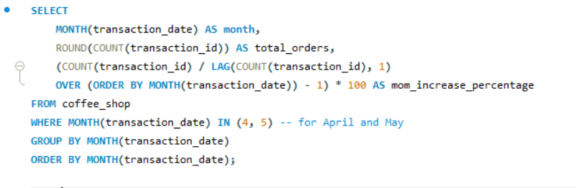

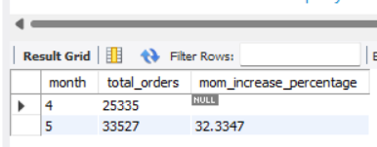

**TOTAL QUANTITY SOLD**

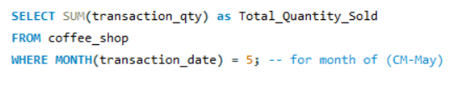

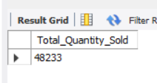

**TOTAL QUANTITY SOLD KPI - MOM DIFFERENCE AND MOM GROWTH**

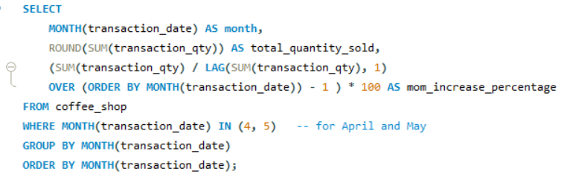

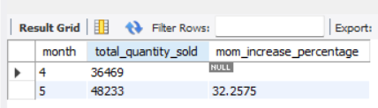

**CALENDAR TABLE – DAILY SALES, QUANTITY and TOTAL ORDERS**

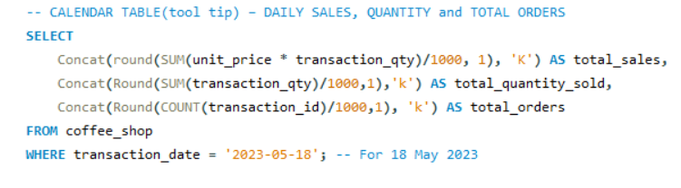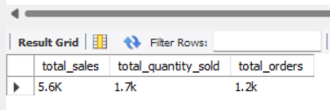

**SALES BY WEEKDAY / WEEKEND:**

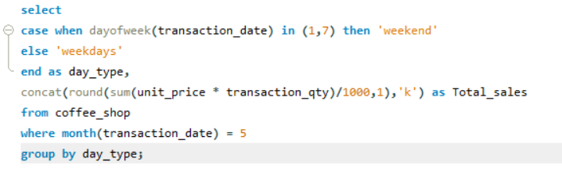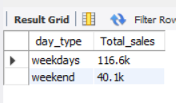

**SALES BY STORE LOCATION**

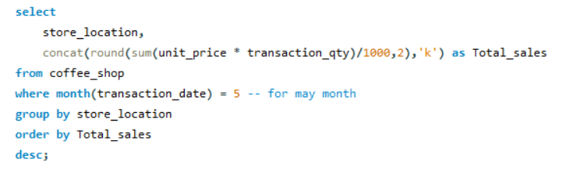

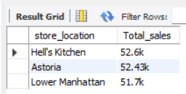

**Daily Saes analysis with product line**

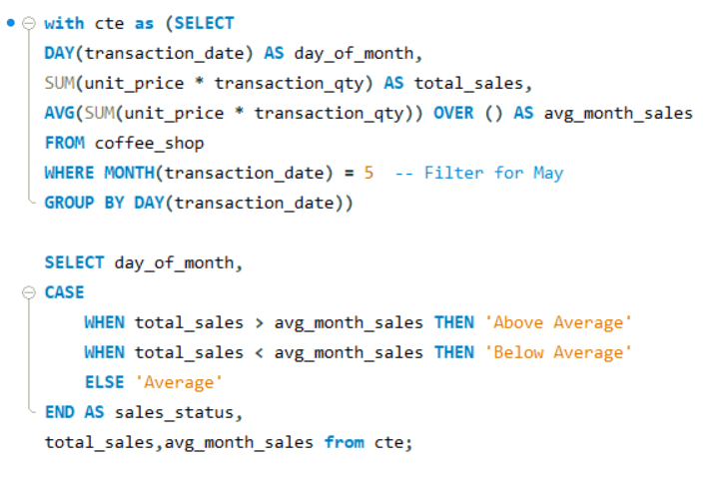

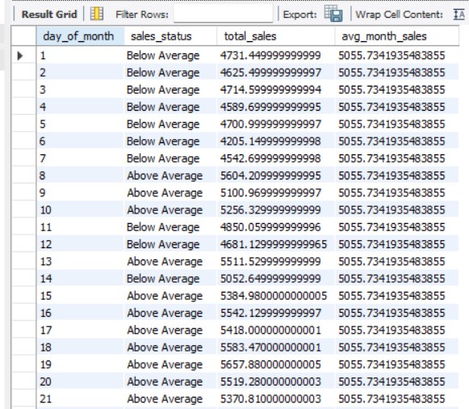

**Sales analysis by product Category**

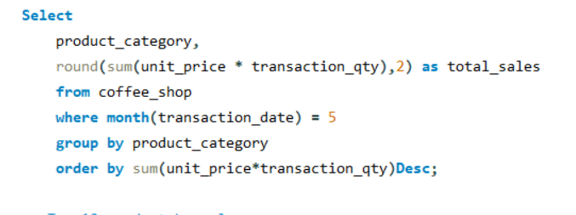

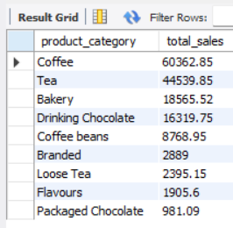

**Top 10 product sale**

